Sarah Cianciola Katie Venzera Joey Sacco

Final Project Reflection CVS Infotainment System

**Prototype:**

**https://xd.adobe.com/view/f2e27e42-88ff-40ce-ad1b-9d3fdefbbfce-a7b1/**

**Rational:**

**Patterns**

In our prototype, we used several different UI patterns to help develop an easy-to-use infotainment system. One pattern we used was similar, since we discovered in our foundational research that most of our users had iPhones, we designed our infotainment system based on an iPhone UI.

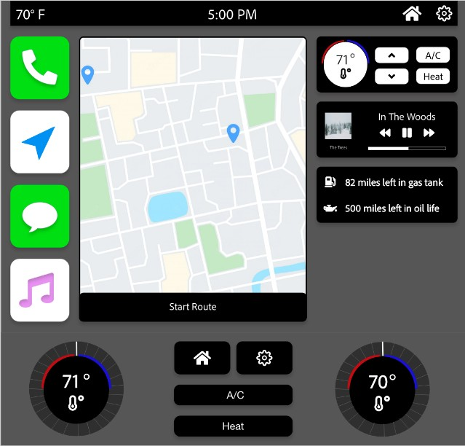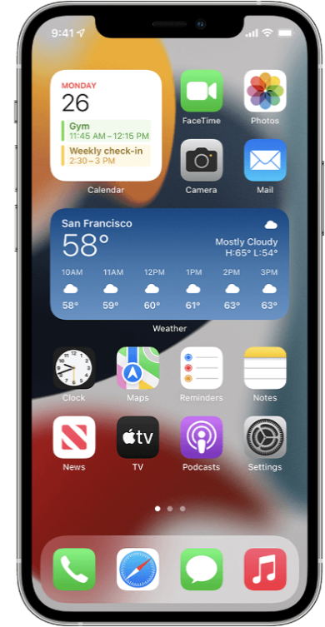

Many of the icons and apps are very similar which relates to the user’s mental model for these functionalities. Another pattern we used was cards, with one example being the ratio sources, each source has its own card, and collectivity these cards formulate a grid, which is another pattern.

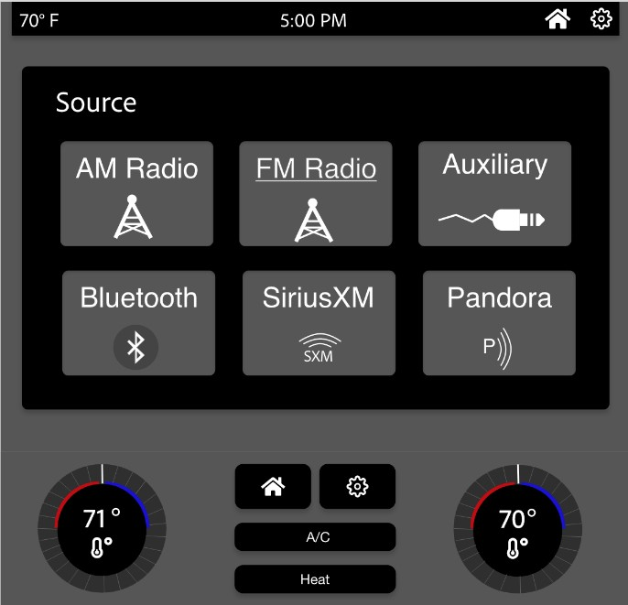

We also chose to create our design based on the pattern of color and particularly using high contrasting colors because from our foundation research we found that many of our users were older and having high contrasting colors could help usability. Additionally, our home screen follows the pattern of a dashboard since there are many different-sided modular sections. This also ties back to the pattern of similarity, having different-sized modules resembles the home screen an iPhone user might choose to use. Finally, each page has an escape hatch being the home icon on the top right corner and in the physical controls, this helps the user return to the dashboard home screen at any time.

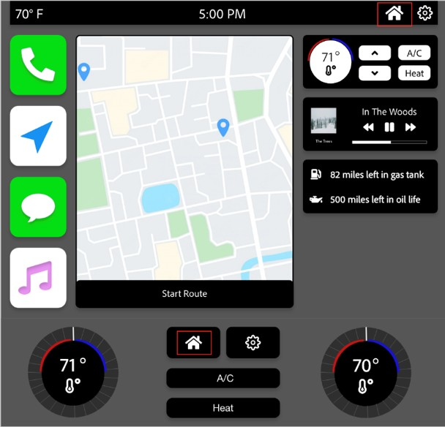

Overall, some design principles we used on the home screen were in contrast as described above with the high contrast of black background with white text. We also used the design principle of proximity by putting apps close together on the left and on the right with all the car details and settings. Also, we used alignment, one example is we aligned all the apps on the left.

# Usability Study

**Findings**

In our results, we found our user’s interaction time to complete a task, was longer than anticipated- based on our calculation KLM. Once we prefaced our users to use “Enter” (now renamed to select) to initiate an interaction, the user’s interaction time to complete a task decreased. Watching our users interact with the infotainment system, we realized how the enter key created extra button pressing.

# Insights

From analyzing our results, we found our user’s mental model regarding functions differed from what we prototyped. This infotainment system's function and design felt foreign for some users as it was not intuitive. However, our users expressed that once they learned the system, it was easier to understand, but the users thought there was a learning curve to the system. The “Enter” (now renamed to select) key to make the highlight appear was not intuitive- this played a significant role in why our user’s interaction time to complete a task was longer. Another factor, our users noted their surprise regarding it took them longer to complete a task than expected when using physical buttons. Another thing our users mentioned was their confusion about why there is two button method for selecting an item on the screen. In addition, users were confused regarding if the icons at the top right are touchable or not for the touch control user cases.

In the usability study, we learned our users generally preferred to use touch controls over the physical ones because it was fewer clicks/movements. However, the temperature controls are normally used through their physical buttons in infotainment systems, especially if they do not have touch controls for that. It seems to stop being a conditioning thing with more experienced drivers who are not used to the much technology

The prototype was usable for the interviewees, as our prototype was fully developed at the time of conducting our interviews as we made it our goal to have it fully functional beforehand. Our prototype provided customization, a few discoverable features, and multiple ways to complete a task. Our SUS scores were: 80, 85, 25, 30, 75, and 72.5, with an average of 61.25 - this indicated our prototype is overall usable. However, there are opportunities to improve our prototype. We were able to learn from the individuals who gave the lower SUS scores since they thought there were a lot of improvement opportunities.

# Improvements

Some improvements we made to the design from the usability study were to create larger buttons/button icons so the user knows what can be pressed. We also grouped the icons that were touchable and the information like the time and temperature to also help the user know what features are clickable.

Some improvements we made to the design were to create larger buttons/button icons so the user knows what can be pressed. We also grouped the icons that were touchable and the information like the time and temperature to also help the user know what features are clickable. We decided to add icons to our source button page after it was brought to our attention that it was only words and no visuals which would be important to accessibility. Then we also added a home icon to the steering wheel and rearranged the buttons on the steering accordingly to accommodate for the home button. Finally, the last change we made was thickening the lines on the highlight for the physical controls to make the highlight more pronounced.

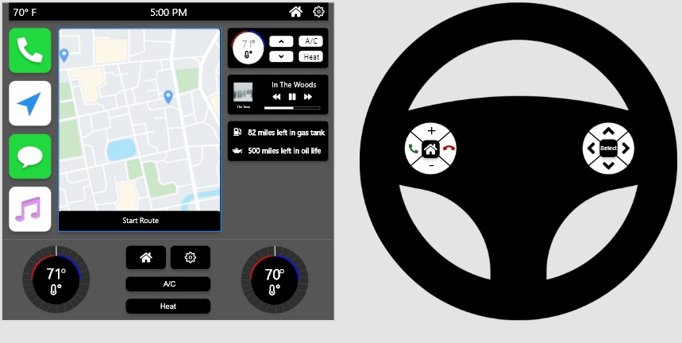

We also noticed that we had an “Enter” and a “Select” button which is the same job but were in different spots and not labeled the same making it seem to the user they have different functionalities, so we decided to remove the one on the center console near our physical temperature control and make the button that said “Enter” on the steering wheel now say “Select”.

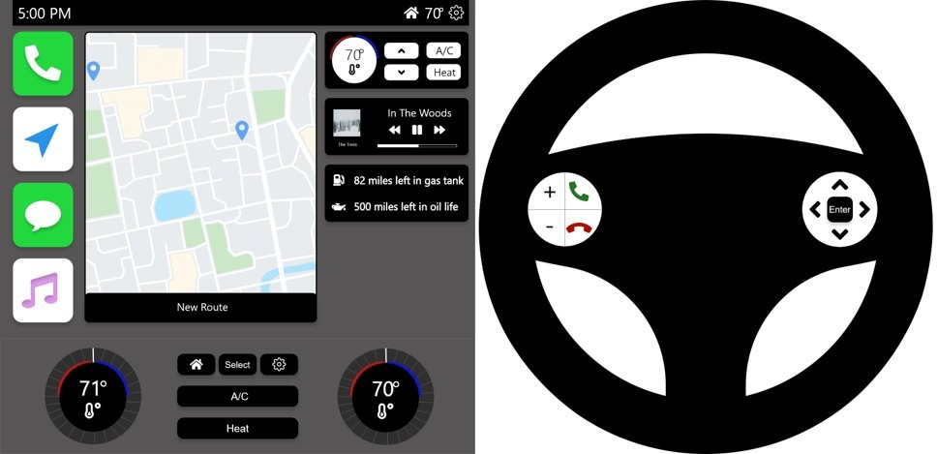

Next, we also changed the look of the home button on the steering wheel to be larger and clearer for our users to see, as well as added the apps to the home screen for audio to increase the consistent use of those applications being displayed across all screens which required the moving of other elements on these screens as well. Finally, we moved the top icons to certain groups based on if they were clickable or not, so the time and temperature are separate from each other as well as the settings icon and home buttons.

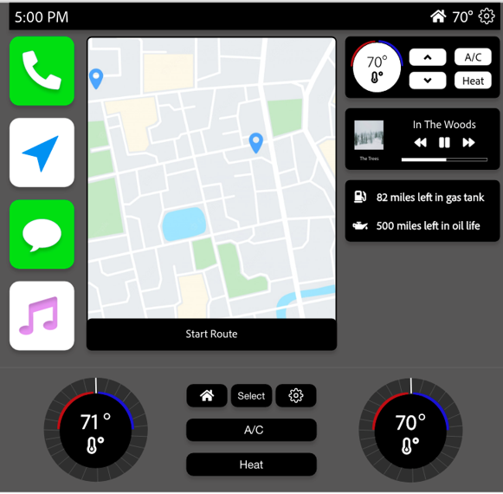

# Test Script:

**Introduction**

I am with [insert names] and we are developing a new infotainment system. We are here today to help understand users’ experiences with our first iteration of our infotainment system to inform our final designs.

Do you have any questions for us before we start?

# Questions – Task-Based

1. How would you change the audio source through touch controls?
2. How would you change the audio source through physical controls?
3. How would you go from audio to navigation using touch controls?
4. How would you go from audio to navigation using physical controls?
5. How would you end a navigation route using touch controls?
6. How would you end a navigation route using physical controls?
7. How would you reject an incoming call using touch controls?
8. How would you reject an incoming call using physical controls?
9. How would you listen to a text using touch controls?
10. How would you listen to a text using physical controls?
11. How would you change the color of the display using touch controls?
12. How would you change the color of the display using physical controls?
13. How would you turn on the A/C and adjust the temperature to 72 degrees using touch controls?
14. How would you turn on the A/C and adjust the temperature to 72 degrees using physical controls?
15. Do you prefer to use touch or physical controls to interact with the infotainment system?

*Ask the SUS questions here*

# Questions - Overall

1. What are your overall thoughts of the infotainment system?
2. What did you find challenging with the infotainment system?
3. If you could change the infotainment system, what would you do?

# Conclusion

Thank you for your time today, your feedback is helpful. Do you have anything else you would like to add?

# System Usability Scale

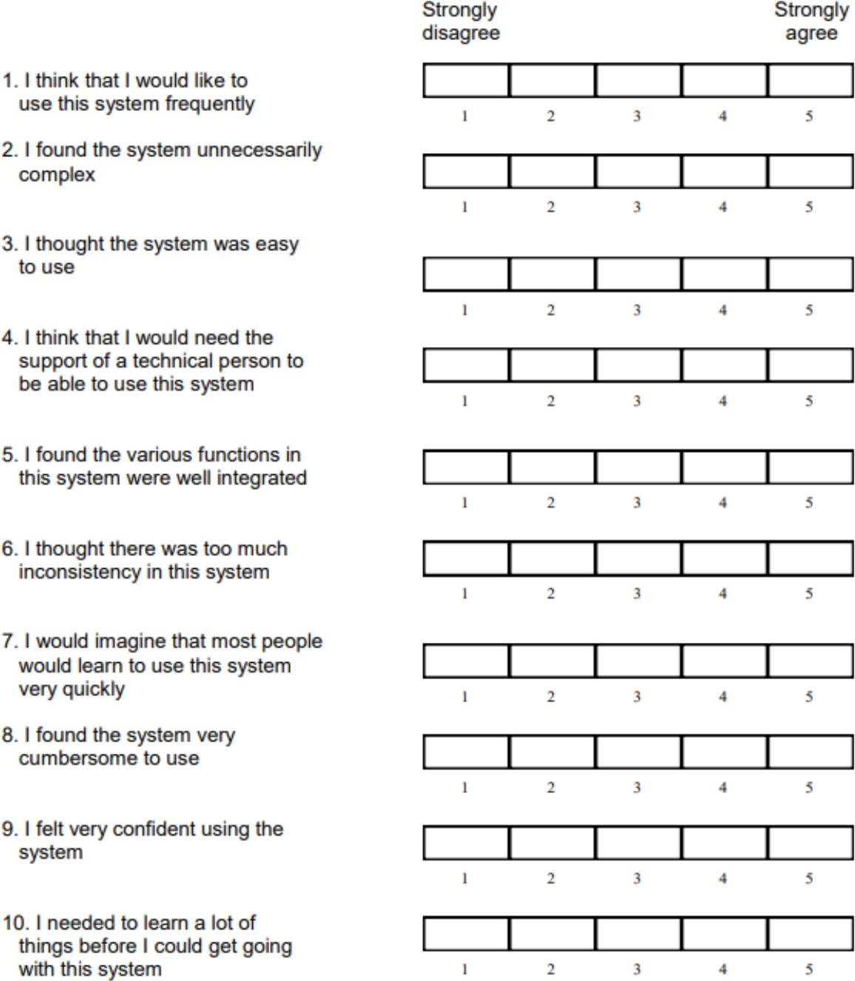

Usability Study Interview Notes - User 1

|  |  |  |
| --- | --- | --- |
| **Task Based Questions** | **Responses** | **# of Clicks** |
| 1.lllHow would you change the audio  source through touch controls? | Easy, the source button easy to find | 3 |

**Introduction Statement:** I am with [insert names] and we

are developing a new infotainment system. We are here today to help understand users’ experiences with our first iteration of our infotainment system to inform our final designs.

Do you have any questions for us before we start?

|  |  |  |
| --- | --- | --- |
| 2. How would you change the audio  source through physical controls? | Easy, once you know you have to hit enter first | 5 |

**Conclusion Statement:** Thank you for your time today.

You have given us a lot of valuable information. We thank

|  |  |  |
| --- | --- | --- |
| 3. How would you go from audio to  navigation using touch controls? | Easy, but the home icon is was little buried | 4 |

**Demographic Information**

|  |  |  |
| --- | --- | --- |
| 4. How would you go from audio to  navigation using physical controls? | When you hit enter it is hard to see where the  highlight is or know where to look | 6 |

|  |  |  |  |
| --- | --- | --- | --- |
| **User #: 1** | **Age &**  **Gender: Female 23** | **Education**  **Level: Masters** | **Job: Store**  **manager and student** |

|  |  |  |
| --- | --- | --- |
| 5. How would you end a navigation route  using touch controls? | Easy, red button easy to see | 6 |

|  |  |  |
| --- | --- | --- |
| 6. How would you end a navigation route  using physical controls? | Easy with the red button | 3 |

|  |  |  |
| --- | --- | --- |
| 7.lllHow would you reject an incoming  call using touch controls? | Pop up is easy to see since the background is burred | 1 |

|  |  |  |
| --- | --- | --- |
| 8.lllHow would you reject an incoming  call using physical controls? | Easy with the reject button on the stirring wheel | 1 |

|  |  |  |
| --- | --- | --- |
| 9. How would you listen to a text using  touch controls? | Easy because it resembles my iPhone | 3 |

|  |  |  |
| --- | --- | --- |
| 10.lllHow would you listen to a text  using physical controls? | Easy to use followed my iPhone | 7 |

|  |  |  |
| --- | --- | --- |
| 11.lllHow would you change the color  of the display using touch controls? | Easy but I do not have a gear icon for settings on my  car only on my iPhone | 5 |

|  |  |  |
| --- | --- | --- |
| 12.lllHow would you change the color  of the display using physical controls? | Easy but a long process | 15 |

|  |  |  |
| --- | --- | --- |
| 13.lllHow would you turn on the A/C  and adjust the temperature to 72 degrees using touch controls? | Easy since it is on the home screen | 4 |

|  |  |  |
| --- | --- | --- |
| 14.lllHow would you turn on the A/C  and adjust the temperature to 72 degrees using physical controls? | Confused what the select button would do | 3 |

|  |  |  |
| --- | --- | --- |
| 15.lllDo you prefer to use touch or  physical controls to interact with the infotainment system? | Touch it is easier to use because there are less  buttons to press | N/A |

|  |  |  |  |  |  |  |  |  |
| --- | --- | --- | --- | --- | --- | --- | --- | --- |
| **SUS Questions** | **Responses** | | | | |  |  |  |
|  | **Strongly Disagree 1** | **2** | **3** | **4** | **Strongly Agree 5** |  |  |  |
| 1. I think that I would like to use this  system frequently. |  |  |  | X |  | 3 | 32 | 80 |

4

|  |  |  |  |  |  |
| --- | --- | --- | --- | --- | --- |
| 2. I found the system unnecessarily  complex. | X |  |  |  |  |

3

|  |  |  |  |  |  |
| --- | --- | --- | --- | --- | --- |
| 3. I thought the system was easy to  use. |  |  |  | X |  |

|  |  |  |  |  |  |
| --- | --- | --- | --- | --- | --- |
| 4. I think that I would need the support  of a technical person to be able to use  this system. |  |  | X |  |  |

2

|  |  |  |  |  |  |
| --- | --- | --- | --- | --- | --- |
| 5. I found the various functions in this  system were well integrated. |  |  |  | X |  |

3

|  |  |  |  |  |  |
| --- | --- | --- | --- | --- | --- |
| 6. I thought there was too much  inconsistency in this system. | X |  |  |  |  |

4

|  |  |  |  |  |  |
| --- | --- | --- | --- | --- | --- |
| 7. I would imagine that most people  would learn to use this system very  quickly. |  |  |  | X |  |

3

|  |  |  |  |  |  |
| --- | --- | --- | --- | --- | --- |
| 8. I found the system very cumbersome  to use. |  | X |  |  |  |

3

3

|  |  |  |  |  |  |
| --- | --- | --- | --- | --- | --- |
| 9. I felt very confident using the  system. |  |  |  | X |  |

|  |  |  |  |  |  |
| --- | --- | --- | --- | --- | --- |
| 10. I needed to learn a lot of things  before I could get going with this  system. | X |  |  |  |  |

4

|  |  |
| --- | --- |
| **Conclusion Questions** | **Responses** |

|  |  |
| --- | --- |
| What are your overall thoughts of the  infotainment system? | Thought it was easy to use it resembled my iPhone really well,  which made it easier to use. The controls from the system were hard to use probably because you have to hit enter, but I do not know how else you would make the selection tool appear. But once you know that it works pretty well for a control based system. |

|  |  |
| --- | --- |
| What did you find challenging with the  infotainment system? | The enter for the selection tool |

|  |  |
| --- | --- |
| If you could change the infotainment  system, what would you do? | Nothing other than the enter some how |

Usability Study Interview Notes - User 2

|  |  |  |
| --- | --- | --- |
| **Task Based Questions** | **Responses** | **# of Clicks** |
| 1.lllHow would you change the audio  source through touch controls? | Changed using the bottom controls, thought that  source was a little confusing | 1 |

**Introduction Statement:** I am with [insert names] and we

are developing a new infotainment system. We are here today to help understand users’ experiences with our first iteration of our infotainment system to inform our final designs.

Do you have any questions for us before we start?

|  |  |  |
| --- | --- | --- |
| 2. How would you change the audio  source through physical controls? | The highlight was not intuitive from the beginning.  Used the touch controls instead. Once you get the first experience doing it you get the idea | 4 |

**Conclusion Statement:** Thank you for your time today.

You have given us a lot of valuable information. We thank

you again for your time.

|  |  |  |
| --- | --- | --- |
| 3. How would you go from audio to  navigation using touch controls? | Used the home icon on the bottom (physical controls)  then found the home icon on the top**lll** | 4 |

**Demographic Information**

|  |  |  |
| --- | --- | --- |
| 4. How would you go from audio to  navigation using physical controls? | Used the home button by the temp controls and then  used the arrow keys | 4 |

|  |  |  |  |
| --- | --- | --- | --- |
| **User #: 2** | **Age &**  **Gender: 20 Male** | **Education**  **Level: Undergrad** | **Job: student** |

|  |  |  |
| --- | --- | --- |
| 5. How would you end a navigation route  using touch controls? | Easy, done completely correct | 2 |

|  |  |  |
| --- | --- | --- |
| 6. How would you end a navigation route  using physical controls? | Would to hit a arrow key to know where the highlight  is at. Probably the down arrow | 3 |

|  |  |  |
| --- | --- | --- |
| 7.lllHow would you reject an incoming  call using touch controls? | Found the reject button | 1 |

|  |  |  |
| --- | --- | --- |
| 8.lllHow would you reject an incoming  call using physical controls? | Used the reject button the stirring wheel | 1 |

|  |  |  |
| --- | --- | --- |
| 9. How would you listen to a text using  touch controls? | Easy was able to follow | 3 |

|  |  |  |
| --- | --- | --- |
| 10.lllHow would you listen to a text  using physical controls? | Easy now that he knew about the enter = highlight | 8 |

|  |  |  |
| --- | --- | --- |
| 11.lllHow would you change the color  of the display using touch controls? | Easy to use but used the setting icon in the physical  button for the settings | 5 |

|  |  |  |
| --- | --- | --- |
| 12.lllHow would you change the color  of the display using physical controls? | Used the setting button below the screen | 10 |

|  |  |  |
| --- | --- | --- |
| 13.lllHow would you turn on the A/C  and adjust the temperature to 72 degrees using touch controls? | Easy to use was able to turn on the A/C and adjust the  temp. | 3 |

|  |  |  |
| --- | --- | --- |
| 14.lllHow would you turn on the A/C  and adjust the temperature to 72 degrees using physical controls? | Easy to use | 4 |

|  |  |  |
| --- | --- | --- |
| 15.lllDo you prefer to use touch or  physical controls to interact with the infotainment system? | Controls because of the highlight almost giving you a  hint where the buttons are and the buttons help me  keep my hands on the wheel | N/A |

|  |  |  |  |  |  |  |  |  |
| --- | --- | --- | --- | --- | --- | --- | --- | --- |
| **SUS Questions** | **Responses** | | | | |  |  |  |
|  | **Strongly Disagree 1** | **2** | **3** | **4** | **Strongly Agree 5** |  |  |  |
| 1. I think that I would like to use this  system frequently. |  |  |  | X |  | 3 | 34 | 85 |

3

|  |  |  |  |  |  |
| --- | --- | --- | --- | --- | --- |
| 2. I found the system unnecessarily  complex. |  | X |  |  |  |

2

|  |  |  |  |  |  |
| --- | --- | --- | --- | --- | --- |
| 3. I thought the system was easy to  use. |  |  | X |  |  |

|  |  |  |  |  |  |
| --- | --- | --- | --- | --- | --- |
| 4. I think that I would need the support  of a technical person to be able to use  this system. | X |  |  |  |  |

4

|  |  |  |  |  |  |  |
| --- | --- | --- | --- | --- | --- | --- |
| 5. I found the various functions in this  system were well integrated. |  |  |  |  | X | 4 |

3

|  |  |  |  |  |  |
| --- | --- | --- | --- | --- | --- |
| 6. I thought there was too much  inconsistency in this system. |  | X |  |  |  |

|  |  |  |  |  |  |  |
| --- | --- | --- | --- | --- | --- | --- |
| 7. I would imagine that most people  would learn to use this system very  quickly. |  |  |  |  | X | 4 |

4

|  |  |  |  |  |  |
| --- | --- | --- | --- | --- | --- |
| 8. I found the system very cumbersome  to use. | X |  |  |  |  |

|  |  |  |  |  |  |  |
| --- | --- | --- | --- | --- | --- | --- |
| 9. I felt very confident using the  system. |  |  |  |  | X | 4 |

3

|  |  |  |  |  |  |
| --- | --- | --- | --- | --- | --- |
| 10. I needed to learn a lot of things  before I could get going with this  system. |  | X |  |  |  |

|  |  |
| --- | --- |
| **Conclusion Questions** | **Responses** |

|  |  |
| --- | --- |
| What are your overall thoughts of the  infotainment system? | Nice interface and matches what I expect from the industry. The  enter key had a little learning curve. |

|  |  |
| --- | --- |
| What did you find challenging with the  infotainment system? | Nothing - enter key, but it wasn't challenging |

|  |  |
| --- | --- |
| If you could change the infotainment  system, what would you do? | For the source button would put a speaker icon |

Usability Study Interview Notes - User 3

|  |  |  |
| --- | --- | --- |
| **Task Based Questions** | **Responses** | **# of Clicks** |
| 1.lllHow would you change the audio  source through touch controls? | Double tap the "FM/AM" to change source- it takes 2  clicks. Should change "source" label to "Audio Source" | 2 clicks |

**Introduction Statement:** I am with [insert names] and we

are developing a new infotainment system. We are here today to help understand users’ experiences with our first iteration of our infotainment system to inform our final designs.

Do you have any questions for us before we start?

|  |  |  |
| --- | --- | --- |
| 2. How would you change the audio  source through physical controls? | Arrow up button- does something pop-up? | 4 |

**Conclusion Statement:** Thank you for your time today.

You have given us a lot of valuable information. We thank

|  |  |  |
| --- | --- | --- |
| 3. How would you go from audio to  navigation using touch controls? | Why's the source and home separate? The home  button is way too small, not where he expected to see it- it's usually at the top left, nearest to driver. Why is there two button methods of selecting/enter? It's unintuitive, why leave one hand on the wheel just to use "select" when there's a "enter" on the wheel. | 3 |

**Demographic Information**

|  |  |  |
| --- | --- | --- |
| 4. How would you go from audio to  navigation using physical controls? | Select home button, arrow keys, enter button (not the  select button) | 4 |

|  |  |  |  |
| --- | --- | --- | --- |
| **User #: 3** | **Age &**  **Gender: 18 & Male** | **Education**  **Level: Full time student** | **Job: Student** |

|  |  |  |
| --- | --- | --- |
| 5. How would you end a navigation route  using touch controls? | Hit "end" | 2 |

|  |  |  |
| --- | --- | --- |
| 6. How would you end a navigation route  using physical controls? | Down arrow, enter, enter. | 3 |

|  |  |  |
| --- | --- | --- |
| 7.lllHow would you reject an incoming  call using touch controls? | Reject button on steering wheel | 2 |

|  |  |  |
| --- | --- | --- |
| 8.lllHow would you reject an incoming  call using physical controls? | Down arrow (auto assumes the selector is the on the  entire screen- to see where it is), | 3-4 clicks |

|  |  |  |
| --- | --- | --- |
| 9. How would you listen to a text using  touch controls? | Tap message icon, tap Sarah, listen | 3 |

|  |  |  |
| --- | --- | --- |
| 10.lllHow would you listen to a text  using physical controls? | Down arrow (3 x), enter, right arrow (assuming still on  icon), enter | 5 |

|  |  |  |
| --- | --- | --- |
| 11.lllHow would you change the color  of the display using touch controls? | Settings, display, color, select color | 4 |

|  |  |  |
| --- | --- | --- |
| 12.lllHow would you change the color  of the display using physical controls? | Settings, down, enter (display), enter (color), enter | 5 |

|  |  |  |
| --- | --- | --- |
| 13.lllHow would you turn on the A/C  and adjust the temperature to 72 degrees using touch controls? | Tap digital up arrows (2x) | 2 |

|  |  |  |
| --- | --- | --- |
| 14.lllHow would you turn on the A/C  and adjust the temperature to 72 degrees using physical controls? | Turn left 2 . He believed the hot was on the right side  of the knob and initially turned it right 2. Said it didn’t make sense to have buttons for a/c and heat because if you turned it to 64 it would be a/c or if he turned it to 74 it would be heat. | 2 |

|  |  |  |
| --- | --- | --- |
| 15.lllDo you prefer to use touch or  physical controls to interact with the infotainment system? | With touch- because the physical was way too  complicated. |  |

|  |  |
| --- | --- |
| **SUS Questions** | **Responses** |

|  |  |  |  |  |  |  |  |  |
| --- | --- | --- | --- | --- | --- | --- | --- | --- |
|  | **Strongly Disagree 1** | **2** | **3** | **4** | **Strongly Agree 5** |  |  |  |
| 1. I think that I would like to use this  system frequently. | 1 |  |  |  |  | 0 | 10 | 25 |

|  |  |  |  |  |  |  |
| --- | --- | --- | --- | --- | --- | --- |
| 2. I found the system unnecessarily  complex. |  |  |  |  | 5 | 0 |

2

|  |  |  |  |  |  |
| --- | --- | --- | --- | --- | --- |
| 3. I thought the system was easy to  use. |  |  | 3 |  |  |

|  |  |  |  |  |  |
| --- | --- | --- | --- | --- | --- |
| 4. I think that I would need the support  of a technical person to be able to use  this system. | 1 |  |  |  |  |

4

|  |  |  |  |  |  |
| --- | --- | --- | --- | --- | --- |
| 5. I found the various functions in this  system were well integrated. | 1 |  |  |  |  |

0

|  |  |  |  |  |  |
| --- | --- | --- | --- | --- | --- |
| 6. I thought there was too much  inconsistency in this system. |  |  | 3 |  |  |

2

|  |  |  |  |  |  |
| --- | --- | --- | --- | --- | --- |
| 7. I would imagine that most people  would learn to use this system very  quickly. |  | 2 |  |  |  |

1

|  |  |
| --- | --- |
| 5- "I love physical buttons and this murdered them" | 0 |

|  |  |  |  |  |
| --- | --- | --- | --- | --- |
| 8. I found the system very cumbersome  to use. |  |  |  |  |

0

|  |  |  |  |  |  |
| --- | --- | --- | --- | --- | --- |
| 9. I felt very confident using the  system. | 1 |  |  |  |  |

|  |  |  |  |  |  |
| --- | --- | --- | --- | --- | --- |
| 10. I needed to learn a lot of things  before I could get going with this  system. |  |  |  | 4 |  |

1

|  |  |
| --- | --- |
| **Conclusion Questions** | **Responses** |

|  |  |
| --- | --- |
| What are your overall thoughts of the  infotainment system? | "I think this needs a lot of work, It seems like the system was focused around the touch feature and neglected the physical button aspect of it. The music and temperature overlays needlessly  took up a portion of the screen instead of just being over a corner of the nav, and the fuel could have just been on the dash. " |

|  |  |
| --- | --- |
| What did you find challenging with the  infotainment system? | "All aspects of the physical buttons. The Settings were unclear and I thought color meant theme but then it changed the color of the text, which was neither the 2 things I thought until it was." |

|  |  |
| --- | --- |
| If you could change the infotainment  system, what would you do? | "The physical buttons were made useless buttons instead of a music  button or a nav button one of the features made accessible to the touch function easily. The buttons were also in a really weird spot, they should be put on the side for ease of access, like there should be 6 buttons and the top left should be hone and the top right should be settings then the two below on the left be things that can be used while driving and the other side be things like music because music is usually the passengers job." |
|  | Subject wrote all this because I am disappointed - subject |

Usability Study Interview Notes - User 4

|  |  |  |
| --- | --- | --- |
| **Task Based Questions** | **Responses** | **# of Clicks** |
| 1.lllHow would you change the audio  source through touch controls? | Source- logic- source of sound, Home-somewhere to  chose Bluetooth, other audio source. "Source" button doesn't look like a button- looks like it's hanging there. | 3-4 clicks |

**Introduction Statement:** I am with [insert names] and we

are developing a new infotainment system. We are here today to help understand users’ experiences with our first iteration of our infotainment system to inform our final designs.

Do you have any questions for us before we start?

|  |  |  |
| --- | --- | --- |
| 2. How would you change the audio  source through physical controls? | Select home button, and arrows to get to AM.  Strongly dislikes the walk-through process of Audio to Nav via physical button. | 3 |

**Conclusion Statement:** Thank you for your time today.

You have given us a lot of valuable information. We thank

you again for your time.

|  |  |  |
| --- | --- | --- |
| 3. How would you go from audio to  navigation using touch controls? | Home button, why is there two navigation? On the  nav page, should be mic | 4 |

**Demographic Information**

|  |  |  |
| --- | --- | --- |
| 4. How would you go from audio to  navigation using physical controls? | Why is there 3 buttons to get to the same location or  do the same task, where's the back button? | 7 |

|  |  |  |  |
| --- | --- | --- | --- |
| **User #: 4** | **Age &**  **Gender: 19, Male** | **Education**  **Level: Full time student** | **Job: Student** |

|  |  |  |
| --- | --- | --- |
| 5. How would you end a navigation route  using touch controls? | Straight forward, simple | 2 |

|  |  |  |
| --- | --- | --- |
| 6. How would you end a navigation route  using physical controls? | Straight forward, as expected, | 3 |

|  |  |  |
| --- | --- | --- |
| 7.lllHow would you reject an incoming  call using touch controls? | "The music should stop completely when a incoming  call comes through, should play a ringtone" | 2 |

|  |  |  |
| --- | --- | --- |
| 8.lllHow would you reject an incoming  call using physical controls? | Is fine | 3 |

|  |  |  |
| --- | --- | --- |
| 9. How would you listen to a text using  touch controls? | "This feature is unsafe for users and anyone else on  the rode with this vehicle. Any feature in a car that encourages distracted driving should not exist and is a detriment to every driver's safety. Remove the words on the screen while the vehicle is not in park and it might be better and safer for everyone." | 3 |

|  |  |  |
| --- | --- | --- |
| 10.lllHow would you listen to a text  using physical controls? | When user taps new message, should auto bring that  convo up. User can hit back to read other new  messages if multiple. | 5 |

|  |  |  |
| --- | --- | --- |
| 11.lllHow would you change the color  of the display using touch controls? | Don't see the need for it but if others want it, I would  never use it. | 4 |

|  |  |  |
| --- | --- | --- |
| 12.lllHow would you change the color  of the display using physical controls? | I wouldn't | 5 |

|  |  |  |
| --- | --- | --- |
| 13.lllHow would you turn on the A/C  and adjust the temperature to 72 degrees using touch controls? | Why is there two temperature knobs? I can see it for  bigger vehicles (bus, SUV), what about where the heat/ac goes- defrost, on feet, etc.? | 2 |

|  |  |  |
| --- | --- | --- |
| 14.lllHow would you turn on the A/C  and adjust the temperature to 72 degrees using physical controls? | Combine A/C with Heat. What about option for just air  blowing on my face- what if I don't want cold or hot  air? | 2 |

|  |  |  |
| --- | --- | --- |
| 15.lllDo you prefer to use touch or  physical controls to interact with the infotainment system? | Touch. Physical requires dead |  |

|  |  |  |  |  |  |  |  |  |
| --- | --- | --- | --- | --- | --- | --- | --- | --- |
| **SUS Questions** | **Responses** | | | | |  |  |  |
|  | **Strongly Disagree 1** | **2** | **3** | **4** | **Strongly Agree 5** |  |  |  |
| 1. I think that I would like to use this  system frequently. | x |  |  |  |  | 0 | 12 | 30 |

|  |  |  |  |  |  |  |
| --- | --- | --- | --- | --- | --- | --- |
| 2. I found the system unnecessarily  complex. |  |  |  |  | x | 0 |

1

|  |  |  |  |  |  |
| --- | --- | --- | --- | --- | --- |
| 3. I thought the system was easy to  use. |  | x |  |  |  |

|  |  |  |  |  |  |
| --- | --- | --- | --- | --- | --- |
| 4. I think that I would need the support  of a technical person to be able to use  this system. | x |  |  |  |  |

4

|  |  |  |  |  |  |
| --- | --- | --- | --- | --- | --- |
| 5. I found the various functions in this  system were well integrated. |  | x |  |  |  |

1

|  |  |  |  |  |  |
| --- | --- | --- | --- | --- | --- |
| 6. I thought there was too much  inconsistency in this system. |  | x |  |  |  |

3

|  |  |  |  |  |  |
| --- | --- | --- | --- | --- | --- |
| 7. I would imagine that most people  would learn to use this system very  quickly. |  | x |  |  |  |

1

|  |  |  |  |  |  |  |
| --- | --- | --- | --- | --- | --- | --- |
| 8. I found the system very cumbersome  to use. |  |  |  |  | x | 0 |

0

|  |  |  |  |  |  |
| --- | --- | --- | --- | --- | --- |
| 9. I felt very confident using the  system. | x |  |  |  |  |

|  |  |  |  |  |  |
| --- | --- | --- | --- | --- | --- |
| 10. I needed to learn a lot of things  before I could get going with this  system. |  |  | x |  |  |

2

|  |  |
| --- | --- |
| **Conclusion Questions** | **Responses** |

|  |  |
| --- | --- |
| What are your overall thoughts of the  infotainment system? | "No D-Pad, I am not playing the nintendo DS LITE while I am driving." |

|  |  |
| --- | --- |
| What did you find challenging with the  infotainment system? | The D-PAD, no D-PAD |

|  |  |
| --- | --- |
| If you could change the infotainment  system, what would you do? | "Remove the texting feature. That is how to kill people. Add control  over the thermostat like where the air comes from, and the speed of the fans. Remove the ac/heat button by you don’t need to determine between ac and not ac. CRUISE CONTROL FOR THE LOVE OF GOD GIVE ME CRUISE CONTROL. Less d-pad more arrows going in one direction." |

Usability Study Interview Notes - User 5

|  |  |  |
| --- | --- | --- |
| **Task Based Questions** | **Responses** | **# of Clicks** |
| 1.lllHow would you change the audio  source through touch controls? | Good size source button, hard to see without glasses  though | 4 |

**Introduction Statement:** I am with [insert names] and we

are developing a new infotainment system. We are here today to help understand users’ experiences with our first iteration of our infotainment system to inform our final designs.

Do you have any questions for us before we start?

|  |  |  |
| --- | --- | --- |
| 2. How would you change the audio  source through physical controls? | Finding out what the steering wheel buttons were  being pressed was a challenge but it was self  explanatory | 7 |

**Conclusion Statement:** Thank you for your time today.

You have given us a lot of valuable information. We thank

you again for your time.

|  |  |  |
| --- | --- | --- |
| 3. How would you go from audio to  navigation using touch controls? | Hard to see the home button at first, but simple once  found | 5 |

**Demographic Information**

|  |  |  |
| --- | --- | --- |
| 4. How would you go from audio to  navigation using physical controls? | Hard to see if the enter button was being hit or not,  but the directional pad is simple to use | 6 |

|  |  |  |  |
| --- | --- | --- | --- |
| **User #: 5** | **Age &**  **Gender: 61, Female** | **Education**  **Level: Masters** | **Job: retired** |

|  |  |  |
| --- | --- | --- |
| 5. How would you end a navigation route  using touch controls? | Large red button is easy to see even without glasses | 7 |

|  |  |  |
| --- | --- | --- |
| 6. How would you end a navigation route  using physical controls? | harder to see when a button is pressed on the  steering wheel, but it was self explanatory | 5 |

|  |  |  |
| --- | --- | --- |
| 7.lllHow would you reject an incoming  call using touch controls? | Easy to see the large red button that popups when a  call is received | 1 |

|  |  |  |
| --- | --- | --- |
| 8.lllHow would you reject an incoming  call using physical controls? | Easy to find the end call button on the steering wheel | 1 |

|  |  |  |
| --- | --- | --- |
| 9. How would you listen to a text using  touch controls? | Easy to navigate to text messages with touch | 4 |

|  |  |  |
| --- | --- | --- |
| 10.lllHow would you listen to a text  using physical controls? | Took a little time to know where to go, but the icons  to press were clear in telling me what it's functionality  was | 7 |

|  |  |  |
| --- | --- | --- |
| 11.lllHow would you change the color  of the display using touch controls? | Needed to ask where the settings would be but once  realized it was a gear icon it was simple | 6 |

|  |  |  |
| --- | --- | --- |
| 12.lllHow would you change the color  of the display using physical controls? | long process and it was hard to see which button was  being pressed but a straight foreword process | 15 |

|  |  |  |
| --- | --- | --- |
| 13.lllHow would you turn on the A/C  and adjust the temperature to 72 degrees using touch controls? | Easy to find the temperature on the infotainment  system screen, just prefers buttons for temp | 4 |

|  |  |  |
| --- | --- | --- |
| 14.lllHow would you turn on the A/C  and adjust the temperature to 72 degrees using physical controls? | Easy to find the physical knobs for the temperature | 2 |

|  |  |  |
| --- | --- | --- |
| 15.lllDo you prefer to use touch or  physical controls to interact with the infotainment system? | Touch because it is less buttons to press, but likes the  physical temperature controls | N/a |

|  |  |  |  |  |  |  |  |  |
| --- | --- | --- | --- | --- | --- | --- | --- | --- |
| **SUS Questions** | **Responses** | | | | |  |  |  |
|  | **Strongly Disagree 1** | **2** | **3** | **4** | **Strongly Agree 5** |  |  |  |
| 1. I think that I would like to use this  system frequently. |  |  |  | X |  | 3 | 30 | 75 |

4

|  |  |  |  |  |  |
| --- | --- | --- | --- | --- | --- |
| 2. I found the system unnecessarily  complex. | X |  |  |  |  |

|  |  |  |  |  |  |
| --- | --- | --- | --- | --- | --- |
| 3. I thought the system was easy to  use. |  |  |  | X |  |

3

|  |  |  |  |  |  |
| --- | --- | --- | --- | --- | --- |
| 4. I think that I would need the support  of a technical person to be able to use  this system. |  |  |  | X |  |

1

|  |  |  |  |  |  |
| --- | --- | --- | --- | --- | --- |
| 5. I found the various functions in this  system were well integrated. |  |  |  | X |  |

3

|  |  |  |  |  |  |
| --- | --- | --- | --- | --- | --- |
| 6. I thought there was too much  inconsistency in this system. | X |  |  |  |  |

4

|  |  |  |  |  |  |
| --- | --- | --- | --- | --- | --- |
| 7. I would imagine that most people  would learn to use this system very  quickly. |  |  |  | X |  |

3

|  |  |  |  |  |  |
| --- | --- | --- | --- | --- | --- |
| 8. I found the system very cumbersome  to use. |  | X |  |  |  |

3

3

|  |  |  |  |  |  |
| --- | --- | --- | --- | --- | --- |
| 9. I felt very confident using the  system. |  |  |  | X |  |

|  |  |  |  |  |  |
| --- | --- | --- | --- | --- | --- |
| 10. I needed to learn a lot of things  before I could get going with this  system. |  | X |  |  |  |

3

|  |  |
| --- | --- |
| **Conclusion Questions** | **Responses** |

|  |  |
| --- | --- |
| What are your overall thoughts of the  infotainment system? | Easy to use and self explanatory, not too different from my current  car's infotainment system |

|  |  |
| --- | --- |
| What did you find challenging with the  infotainment system? | Some button sizes made them unclear or hard to see without  glasses |

|  |  |
| --- | --- |
| If you could change the infotainment  system, what would you do? | Increase the size of the navigational pad on the steering wheel |

Usability Study Interview Notes - User 6

|  |  |  |
| --- | --- | --- |
| **Task Based Questions** | **Responses** | **# of Clicks** |
| 1.lllHow would you change the  audio source through touch controls? | Simple to find with source button, may need to  enlarge if the person cannot see as well | 4 |

**Introduction Statement:** I am with [insert names] and we

are developing a new infotainment system. We are here today to help understand users’ experiences with our first iteration of our infotainment system to inform our final designs.

Do you have any questions for us before we start?

|  |  |  |
| --- | --- | --- |
| 2. How would you change the audio  source through physical controls? | Once it was realized how to use the "buttons", it  came easy | 6 |

**Conclusion Statement:** Thank you for your time today. You

have given us a lot of valuable information. We thank you

again for your time.

|  |  |  |
| --- | --- | --- |
| 3. How would you go from audio to  navigation using touch controls? | Easy to use, just needs the home button to be  larger | 5 |

**Demographic Information**

|  |  |  |
| --- | --- | --- |
| 4. How would you go from audio to  navigation using physical controls? | It was easy to navigate as well, just had trouble  seeing when the enter button is pushed, if it is | 6 |

|  |  |  |  |
| --- | --- | --- | --- |
| **User #: 6** | **Age &**  **Gender: 20, Female** | **Education**  **Level: Sophomore** | **Job:**  **Waitress, Teacher at** |

|  |  |  |
| --- | --- | --- |
| 5. How would you end a navigation  route using touch controls? | The large red end button is easily identifiable | 6 |

|  |  |  |
| --- | --- | --- |
| 6. How would you end a navigation  route using physical controls? | The physical controls are a little small and hard to  see when each one is pressed, but simple | 4 |
| 7.lllHow would you reject an  incoming call using touch controls? | Simple wayfinding by blurring the background and  showing the popup only, then giving good CTA's  for what to do next | 1 |

|  |  |  |
| --- | --- | --- |
| 8.lllHow would you reject an  incoming call using physical controls? | Easy to see the "deny/end call" button on the  controls | 1 |

|  |  |  |
| --- | --- | --- |
| 9. How would you listen to a text  using touch controls? | Easy to figure out as it works like my phone | 3 |

|  |  |  |
| --- | --- | --- |
| 10.lllHow would you listen to a text  using physical controls? | Similar to the touch, but with physical buttons  making a longer process | 6 |

|  |  |  |
| --- | --- | --- |
| 11.lllHow would you change the  color of the display using touch controls? | Easy to figure out where the settings button was  based on icons like the gear | 5 |

|  |  |  |
| --- | --- | --- |
| 12.lllHow would you change the  color of the display using physical controls? | Took a little longer than originally thought, but it  was self explanatory | 11 |

|  |  |  |
| --- | --- | --- |
| 13.lllHow would you turn on the  A/C and adjust the temperature to  72 degrees using touch controls? | Easy to see where it is located on the infotainment  system, maybe some bigger buttons | 4 |

|  |  |  |
| --- | --- | --- |
| 14.lllHow would you turn on the  A/C and adjust the temperature to  72 degrees using physical controls? | Having there own specific buttons makes this easy  to do | 3 |

|  |  |  |
| --- | --- | --- |
| 15.lllDo you prefer to use touch or  physical controls to interact with the infotainment system? | Touch since there is normally less movements to  make and buttons to press | N/a |

|  |  |
| --- | --- |
| **SUS Questions** | **Responses** |

|  |  |  |  |  |  |  |  |  |
| --- | --- | --- | --- | --- | --- | --- | --- | --- |
|  | **Strongly Disagree 1** | **2** | **3** | **4** | **Strongly Agree 5** |  |  |  |
| 1. I think that I would like to use  this system frequently. |  |  |  | X |  | 3 | 29 | 72.5 |

4

|  |  |  |  |  |  |
| --- | --- | --- | --- | --- | --- |
| 2. I found the system unnecessarily  complex. | X |  |  |  |  |

|  |  |  |  |  |  |
| --- | --- | --- | --- | --- | --- |
| 3. I thought the system was easy to  use. |  |  | X |  |  |

2

|  |  |  |  |  |  |
| --- | --- | --- | --- | --- | --- |
| 4. I think that I would need the  support of a technical person to be able to use this system. |  |  | X |  |  |

2

|  |  |  |  |  |  |
| --- | --- | --- | --- | --- | --- |
| 5. I found the various functions in  this system were well integrated. |  |  |  | X |  |

3

|  |  |  |  |  |  |
| --- | --- | --- | --- | --- | --- |
| 6. I thought there was too much  inconsistency in this system. | X |  |  |  |  |

4

|  |  |  |  |  |  |
| --- | --- | --- | --- | --- | --- |
| 7. I would imagine that most  people would learn to use this  system very quickly. |  |  | X |  |  |

2

|  |  |  |  |  |  |
| --- | --- | --- | --- | --- | --- |
| 8. I found the system very  cumbersome to use. | X |  |  |  |  |

4

3

|  |  |  |  |  |  |
| --- | --- | --- | --- | --- | --- |
| 9. I felt very confident using the  system. |  |  |  | X |  |

|  |  |  |  |  |  |
| --- | --- | --- | --- | --- | --- |
| 10. I needed to learn a lot of things  before I could get going with this  system. |  |  | X |  |  |

2

|  |  |
| --- | --- |
| **Conclusion Questions** | **Responses** |

|  |  |
| --- | --- |
| What are your overall thoughts of  the infotainment system? | It was pretty straight foreword to use overall, and it had a lot of  familiar icons and features that are used in other interfaces I use  on a daily basis |

|  |  |
| --- | --- |
| What did you find challenging with  the infotainment system? | The size of some of the buttons |

|  |  |
| --- | --- |
| If you could change the  infotainment system, what would you do? | Larger buttons? |

# Roles:

Sarah:

* A/C Wireframes (touch & controls)
* Change the color (touch & controls)
* 2 Interviews for usability test
* Patterns part of the rational document Kat:
* Auto to Nav (touch & controls)
* End Nav (touch & controls)
* Reject Incoming Call (touch & controls)
* Listen to Text Message (touch & controls)
* 2 Interviews for usability test
* Usability Study section of rationale document
* Forgiveness, Insight 3 (Distractions), Insight 4 (Confusion)

Joey:

* Change audio AM to FM
* 2 interviews for the usability test
* Saliency section of the presentation
* Improvement opportunities of the rational document